

**Capstone Project Report**

**Report 4 – Software Design Document**

– Hanoi, August 2019 –

**Table of Contents**

I. Record of Changes 3

II. Software Design Document 4

1. System Design 4

1.1 System Architecture 4

1.2 Package Diagram 4

2. Database Design 4

3. Detailed Design 5

3.1 <Feature/Function Name1> 5

3.2 <Feature/Function Name2> 6

# I. Record of Changes

|  |  |  |  |
| --- | --- | --- | --- |
| Date | A* M, D | In charge | Change Description |
|  |  |  |  |
|  |  |  |  |
|  |  |  |  |
|  |  |  |  |
|  |  |  |  |
|  |  |  |  |
|  |  |  |  |
|  |  |  |  |
|  |  |  |  |
|  |  |  |  |
|  |  |  |  |
|  |  |  |  |
|  |  |  |  |

*A - Added M - Modified D - Deleted

# II. Software Design Document

## 1. System Design

### 1.1 System Architecture

*[The content of this section includes the overall diagram which includes the sub-systems, the external systems, and the relationship/connection among them. You need also provide the explanation for each of the diagram components (modules, sub-systems, external systems, etc.)].*

### 1.2 Package Diagram

*[Provide the package diagram for each sub-system. The content of this section includes overall package diagram(s) and the explanation for each package (or namespace). Please see the sample and description table format below]*

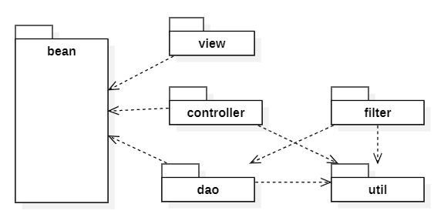

***Package Descriptions***

|  |  |  |
| --- | --- | --- |
| **No** | **Package** | **Description** |
| 01 | <Package name> | <Description of the package> |
| 02 |  |  |

## 2. Database Design

*[Provide the files description, database table relationship & table descriptions like example below]*

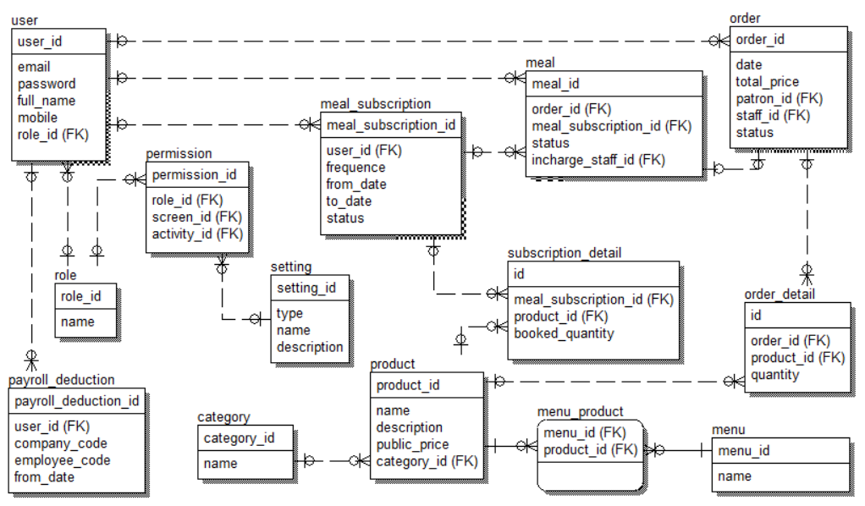

***Table Descriptions***

|  |  |  |
| --- | --- | --- |
| **No** | **Table** | **Description** |
| *01* | *<Table name>* | *<Description of the table>*  *- Primary keys: <<list of primary key fields>>*  *- Foreign keys: <<list of foreign key fields>>* |
| *02* | *<Table name2>* | *…* |

## 3. Detailed Design

### 3.1 <Feature/Function Name1>

*[Provide the detailed design for the feature <Feature Name1>. It includes Class Diagram, Class Specifications, and Sequence Diagram(s);* ***For the features/functions with the same structure of class & sequence diagrams, you need to provide the diagrams once for one feature/function and refer to those diagrams from other features/functions****]*

#### 3.1.1 Class Diagram

*[This part presents the class diagram for the relevant feature]*

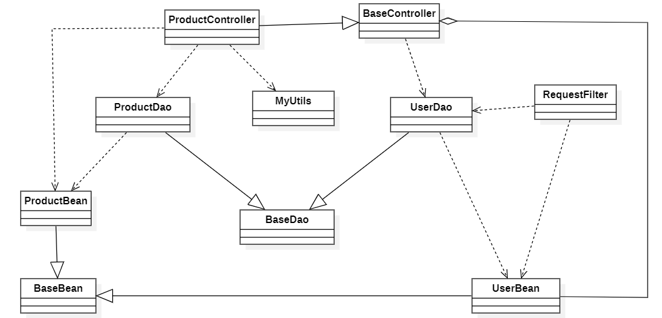

***3.1.2 <Sequence Diagram Name1>***

*[Provide the sequence diagram(s) for the feature, see the sample below]*

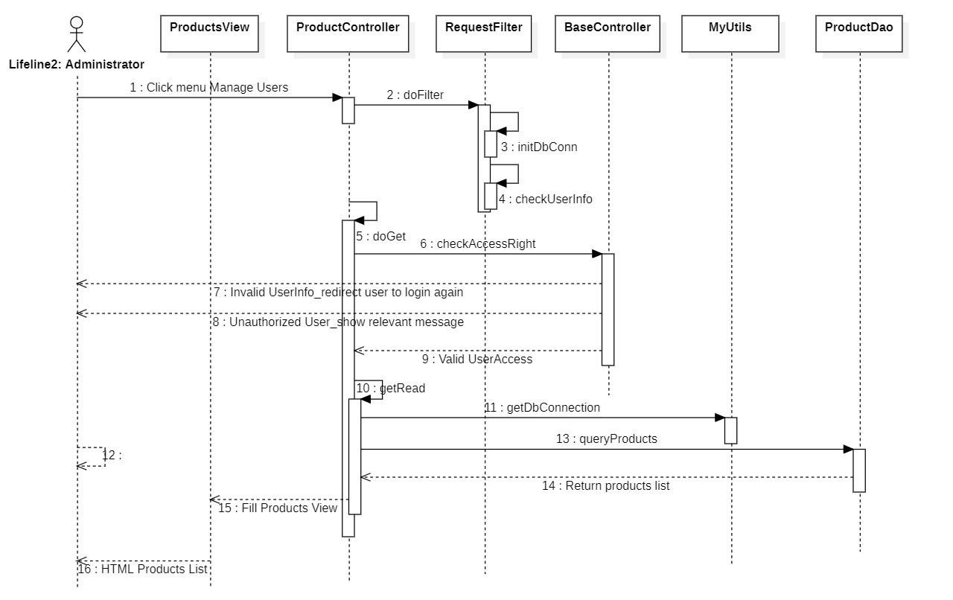

#### 3.1.3 <Sequence Diagram Name2>

#### 3.1.4 …

### 3.2 <Feature/Function Name2>

…